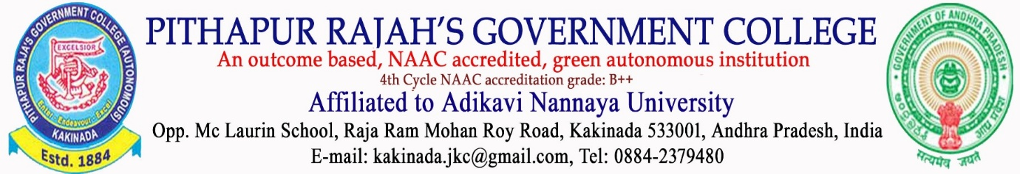

DEPARTMENT OF MATHEMATICS
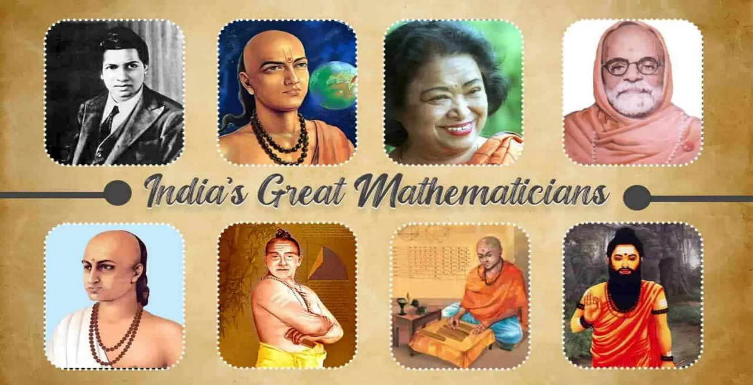

Academic Enrichment Programme Inauguration of Certificate Courses

DATE: 18th DECEMBER 2025

1 | Date | 18 DECEMBER 2025
2 | Conducted through DRC/JKC/ELF/Dept.etc | Department of Mathematics
3 | Nature of Activity | Academic Enrichment Programme -Inauguration of Certificate Courses
4 | Title of Activity | Inauguration of Certificate Courses
5 | Name of the Department / Committee | Department of Mathematics
6 | Details of Resource person | IQAC Co-ordinator-Dr.Hariram Prasad & Faculty of Department of Mathematics
7 | No.of students participated | 90
8 | Activity outcomes: | - Improved understanding of Indian mathematical heritage  - Increased student interest in historical mathematics  - Enhanced analytical and problem-solving skills  - Promotion of cultural and academic integration
9 | Name of the lecturer who planned and conducted the activity | Department of Mathematics
10 | Signature of the In-charge | 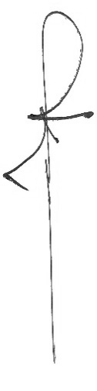
11 | Signature of the Principal | 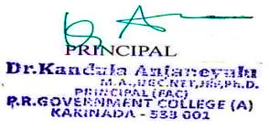


INAUGURATION
OF
CERTIFICATE COURSE

DEPARTMENT OF MATHEMATICS

TITLES:
- ANCIENT INDIAN MATHEMATICS (II YEAR MATHEMATICS MAJOR)
- MATHEMATICS IN INDIA (I YEAR MATHEMATICS MAJOR)

DATE: 18th DECEMBER 2025

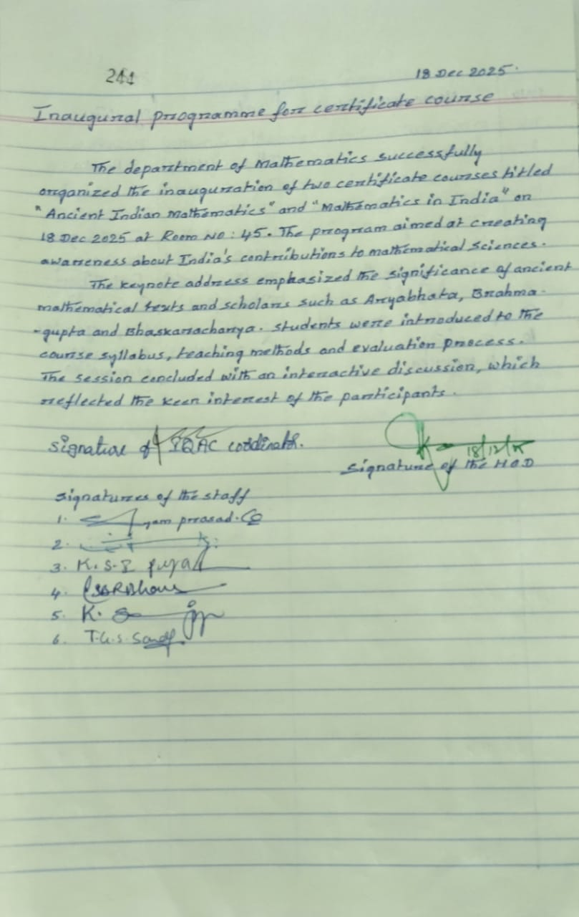

Academic Enrichment Programme Inauguration of Certificate Courses
CERTIFICATE COURSE DETAILS

Name of the Certificate Courses

Course I
Title: Ancient Indian Mathematics
Target Group: II Year B.Sc. Mathematics Major
Course Duration: 30 / 40 Hours
Credits: Nil (Certificate Course)
Course Coordinator: G. PRASADA RAO

Course II
Title: Mathematics in India
Target Group: I Year B.Sc. Mathematics Major
Course Duration: 30 / 40 Hours
Credits: Nil (Certificate Course)
Course Coordinator: L.S.B.R.BHANU

NEED FOR THE COURSE
- Indian mathematics has significantly influenced global mathematical development.
- Regular syllabi often provide limited exposure to historical perspectives.
- The certificate courses aim to bridge this gap by introducing students to India’s indigenous knowledge systems.
- These courses promote value-based education and cultural awareness.

OBJECTIVES

Objectives of the Certificate Courses
- To familiarize students with ancient Indian mathematical texts and scholars
- To explore indigenous methods of calculation and reasoning
- To relate historical concepts to modern mathematical applications
- To promote research interest in the history of mathematics

Objectives of the Inauguration Programme
- To formally announce the commencement of the certificate courses
- To explain course outcomes, structure, and assessment
- To motivate students for active participation

Programme Schedule
Time | Session
10:30 a.m. | Invocation
10:35 a.m. | Welcome Address
10:40 a.m. | Presidential Address
10:45 a.m. | Inauguration & Course Launch
10:50 a.m. | Keynote Address
11:15 a.m. | Course Orientation
11:30 a.m. | Student Interaction
11:45 a.m. | Vote of Thanks
12:00 noon | National Anthem

DETAILED COURSE STRUCTURE

Course I: Ancient Indian Mathematics
Unit I: Origin and Development of Mathematics in Ancient India
Unit II: Sulba Sutras and Geometrical Concepts
Unit III: Vedic Mathematics – Sutras and Applications
Unit IV: Aryabhata, Brahmagupta, Bhaskara – Contributions
Unit V: Relevance of Ancient Methods in Modern Mathematics

Course II: Mathematics in India
Unit I: Evolution of Mathematics in India
Unit II: Arithmetic and Algebra in Indian Texts
Unit III: Trigonometry and Calculus in India
Unit IV: Kerala School of Mathematics
Unit V: Global Impact of Indian Mathematics

TEACHING & LEARNING STRATEGIES
- Chalk-and-talk method
- ICT-enabled presentations
- Demonstration of traditional calculation techniques
- Student seminars and assignments
- Group discussions

EVALUATION & CERTIFICATION

Grade Certificate:

Grade certificate, based on evaluation of final exam, will be issued by department of Mathematics, Pithapur Rajah’s Government College(A), Kakinada.

- Grade O – 90% and above
- Grade A⁺ – 85% and less than 90%
- Grade A – 70% to less than 84%
- Grade B – 60% to less than 69%
- Grade C – 50% to less than 59%
- Grade F – below 49%
- Minimum Attendance: 75%
- Internal Assessment / Assignment
- Participation in discussions
- Certificate issued by the Department after completion

BRIEF REPORT OF THE INAUGURAL PROGRAMME
The Department of Mathematics successfully organized the inauguration of two certificate courses titled “Ancient Indian Mathematics” and “Mathematics in India” on 18 December 2025. The program aimed at creating awareness about India’s contributions to mathematical sciences.
The keynote address emphasized the significance of ancient mathematical texts and scholars such as Aryabhata, Brahmagupta, and Bhaskaracharya. Students were introduced to the course syllabus, teaching methods, and evaluation process. The session concluded with an interactive discussion, which reflected the keen interest of the participants

PARTICIPANT DETAILS

Number of Participants
Category | Count
I Year B.Sc. Mathematics | 48
II Year B.Sc. Mathematics | 42
Total | 90

OUTCOMES & IMPACT

Outcomes
- Improved understanding of Indian mathematical heritage
- Increased student interest in historical mathematics
- Enhanced analytical and problem-solving skills
- Promotion of cultural and academic integration

Long-Term Impact
- Encourages interdisciplinary research
- Builds awareness of Indian Knowledge Systems
- Supports institutional quality enhancement initiatives

Conclusion
The inauguration ceremony successfully launched the certificate courses and strengthened the department’s efforts to promote Indian mathematical heritage among students.
Photo Gallery
